User Manual for Kondoa Girls Secondary School Student Information Management System

Introduction

Welcome to the Kondoa Girls Secondary School Student Information Management System. This manual provides guidance on how to log in and navigate the system effectively.

System Overview

The Student Information Management System is designed to manage student data efficiently, allowing users to access important information and perform various tasks related to student management.

Login Instructions

Accessing the Login Page

Open your web browser.

Enter the URL for the Kondoa Girls Secondary School Student Information Management System.

Logging In

Username: Enter your username in the designated field. This information should be provided by your system administrator.

Password: Enter your password in the password field.

Keep Me Signed In: If you wish to remain logged in on the device you are using, check this box.

Login Button: Click the "Login" button to access the system.

Troubleshooting Login Issues

Forgot Password: If you forget your password, contact your system administrator to reset it.

Username Issues: Ensure you have the correct username and that it is entered accurately.

System Features

Once logged in, you will have access to various features, including:

Viewing student records

Updating student information

Generating reports

Communicating with faculty and administration

Support and Contact Information

If you encounter any issues or have questions regarding the system, please contact your system administrator or the IT support team at the school.

Conclusion

This manual is designed to help you get started with the Kondoa Girls Secondary School Student Information Management System. For further assistance, refer to your system administrator.

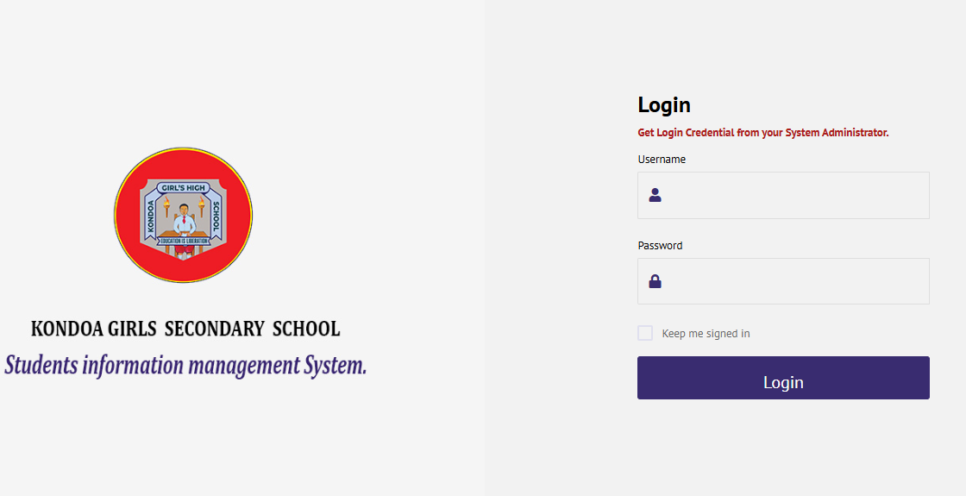

Main Navigation

Once logged in, you will see the main navigation panel on the left side of the screen. Here’s a brief overview of the sections:

Dashboard: Overview of key metrics and data visualizations related to school performance and student admissions.

Admission: Manage student admissions and related processes.

Exam_Settings: Configure exam parameters and settings.

Main_Setting: Access general system settings.

Record_Results: View and manage student academic records and results.

Student_Attendance: Track student attendance records.

System_Users: Manage user accounts and permissions.

Features Overview

Dashboard

School Performance: This section displays a bar chart illustrating the school’s performance over the years.

Students Admission: A line chart showing trends in student admissions over the years.

Accessing Features

To access any feature:

Click on the respective section in the main navigation panel.

Follow on-screen prompts to perform tasks related to that section.

User Interface Elements

Version Information: Located at the bottom of the dashboard, indicating the current version of the system (e.g., Version 0.1).

Copyright Notice: Shows the copyright information for Kondoa Girls High School.

Support and Contact Information

For questions or technical issues, please reach out to your system administrator or the IT support team.

Conclusion

This manual serves as a guide to help you navigate the Kondoa Girls Secondary School Student Information Management System effectively. For additional assistance, please consult your system administrator.

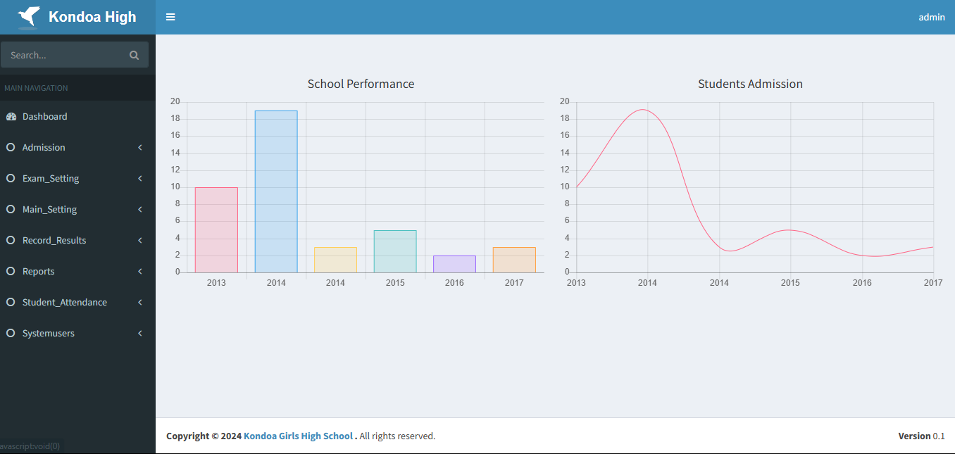

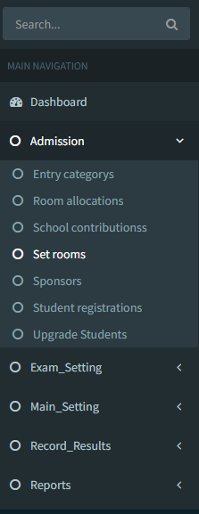Accessing Admission Settings

Log In: Ensure you are logged into the system using your credentials.

Main Navigation: Locate the Admission section in the main navigation panel on the left side of the screen.

Features under Admission

1. Entry Categories

Purpose: Manage different categories for student admissions.

Functionality: Add, edit, or delete entry categories as needed.

2. Room Allocations

Purpose: Assign rooms for various activities or student groups.

Functionality: Manage room assignments for classes, exams, or events.

3. School Contributions

Purpose: Track contributions made to the school by students or sponsors.

Functionality: Input and manage financial or material contributions.

4. Sponsors

Purpose: Manage information related to sponsors supporting students or school activities.

Functionality: Add or edit sponsor details as required.

5. Student Registrations

Purpose: Handle the registration process for new students.Functionality: Input and manage student registration information.

6. Set Rooms

Purpose: Manage and configure room settings for classes and exams. Functionality: Allocate rooms based on requirements. How to Use Each Feature Set Rooms Click on Set rooms from the Admission menu. To add a new room, click the Add Room button.Fill in the necessary details, such as room number, capacity, and purpose. Save your changes. Entry Categories Click on Entry categories.

Use the Add button to create a new category. Enter the relevant details and save. Room Allocations

Select Room allocations. Click on the Allocate Room button to assign rooms to classes or activities.

Fill in the required information and save. School Contributions Click on School contributions. Use the Add Contribution button to input details about contributions.Save your entries.SponsorsSelect Sponsors from the menu.

Click Add Sponsor to enter new sponsor information Save after filling in the details. Student RegistrationsClick on Student registrations. Use the Register Student button to input new student data.

Ensure all required fields are filled, then save.

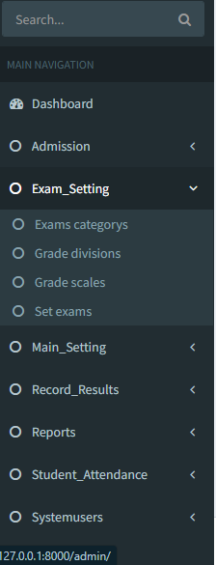Accessing Exam Settings

Log In: Ensure you are logged into the system using your credentials.

Main Navigation: Locate the Exam_Setting section in the main navigation panel on the left side of the screen.

Features under Exam Settings

1. Exam Categories

Purpose: Manage different categories of exams (e.g., midterms, finals).

Functionality: You can add, edit, or delete exam categories.

2. Grade Divisions

Purpose: Define the divisions or segments for grading (e.g., A, B, C).

Functionality: Configure and customize grade divisions according to school policy.

3. Grade Scales

Purpose: Set up grading scales that determine how student performance is evaluated.

Functionality: Adjust numeric values associated with each grade division.

4. Set Exams

Purpose: Create and manage specific exams for different subjects and grades.

Functionality: Input exam details, including dates, subjects, and associated categories.

How to Use Each Feature Exam Categories Click on Exams categories from the Exam_Setting menu.To add a new category, click the Add button.

Fill in the required details and save Grade Divisions Click on Grade divisions from the Exam_Setting menu. To create a new division, click the Add button. Enter the division name and criteria, then save your changes. Grade Scales Select Grade scales from the menu. To edit or add a scale, click the Edit or Add button. Input the scale details and save. Set Exams Click on Set exams. Use the Add Exam button to create a new exam. Enter the necessary information and save.

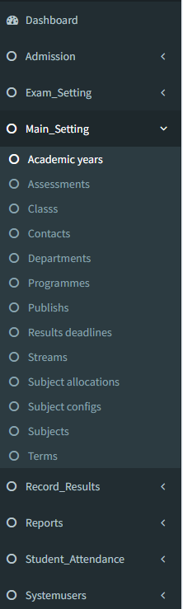Accessing Main Settings

Log In: Ensure you are logged into the system with your credentials.

Main Navigation: Find the Main_Setting section in the main navigation panel on the left side of the screen.

Features under Main Settings

1. Academic Years

Purpose: Manage and define the academic calendar for the school.

Functionality: Add or edit academic years and their respective terms.

2. Assessments

Purpose: Configure various assessment types and criteria.

Functionality: Create and manage assessments used throughout the academic year.

3. Class Management

Purpose: Handle the organization and details of different classes.

Functionality: Add, edit, or delete classes as needed.

4. Contacts

Purpose: Manage contact information for students, parents, and staff.

Functionality: Update or add contact details relevant to school operations.

5. Departments

Purpose: Organize academic and administrative departments within the school.

Functionality: Create and manage departments and their associated staff.

6. Programmes

Purpose: Define the various academic programmes offered by the school.

Functionality: Add or modify programmes as necessary.

7. Publishes

Purpose: Manage the publication of academic materials and announcements.

Functionality: Control what information is published and when.

8. Results Deadlines

Purpose: Set deadlines for the submission of results and assessments.

Functionality: Manage important dates related to academic evaluations.

9. Subject Allocations Purpose: Assign subjects to different classes and teachers. Functionality: Ensure each class has the appropriate subjects assigned.

10. Subjects

Purpose: Manage the list of subjects offered in the school.: Add, edit, or remove subjects as necessary.

11. Terms

Purpose: Define the terms within the academic year.Functionality: Manage term dates and details.

How to Use Each Feature Academic Years Click on Academic years. Use the Add Academic Year button to create a new year.

Fill in the year details and save. Assessments Select Assessments. Click the Add Assessment button to create a new assessment type. Enter the necessary details and save your changes.

Class Management

Click on Class.Use the Add Class button to create a new class.Fill in the class details and save.

Contacts

Select Contacts.

Click on the Add Contact button to enter new contact information. Save the changes after inputting details.

Departments

Click on Departments.

Use the Add Department button to create a new department. Enter the relevant details and save.

Programmes

Select Programmes.

Click the Add Programme button to create or modify a programme. Save your changes once all details are filled in.

Publishes Click on Publishes. Use the Add Publish button to manage publications.

Fill in the required information and save. Results Deadlines Select Results deadlines. Click on the Add Deadline button to set new submission dates. Save your entries after completing the details.

Subject Allocations Click on Subject allocations.Use the Allocate Subjects button to assign subjects to classes.

Ensure all details are filled in, then save. Subjects

Click on Subjects.

Use the Add Subject button to create a new subject. Save your changes after entering the necessary information.

Terms

Select Terms.

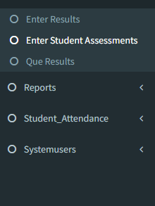Click on the Add Term button to define a new term. Fill in the term details and save.

Accessing Results Management

Log In: Ensure you are logged into the system with your credentials.

Main Navigation: Locate the Enter Results section in the main navigation panel on the left side of the screen.

Features under Results Management

1. Enter Student Assessments

Purpose: Input and manage assessment scores for students.

Functionality: Allows teachers to record individual student assessments for various subjects.

2. Que Results

Purpose: Manage and queue results for processing or publication.

Functionality: Organize results before they are finalized and made available to students.

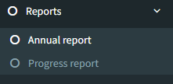

Accessing Reports

Log In: Ensure you are logged into the system with your credentials.

Main Navigation: Locate the Reports section in the main navigation panel on the left side of the screen.

Features under Reports

1. Annual Report

Purpose: Generate comprehensive reports summarizing a student's performance over the entire academic year.

Functionality: Provide insights into academic achievements, attendance, and overall progress.

2. Progress Report

Purpose: Create reports detailing a student's performance over a specific term or period.

Functionality: Track and assess student progress, highlighting strengths and areas for improvement.

How to Use Each Report Feature

Annual Report

Click on Annual Report in the Reports section.

Select the relevant academic year and class for which you wish to generate the report.

Specify any additional parameters, such as subjects or student groups.

Click Generate Annual Report to create the report.

Review the generated report and download or print as needed.

Progress Report

Select Progress Report from the Reports menu.

Choose the term or period for which you want to generate the report.

Select the class and any specific students if needed.

Click Generate Progress Report to create the report.

Review the report details and save or print it as required.